International Womensday Celebrated on

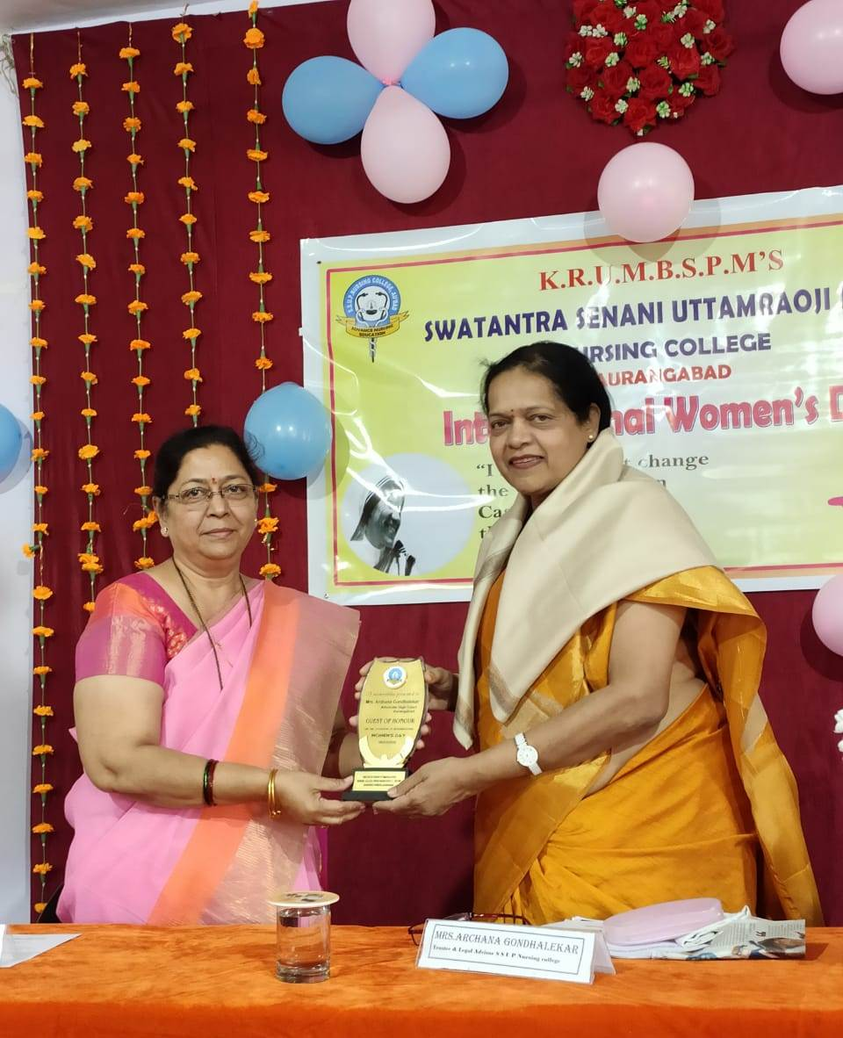

**Our** **Beloved President Mrs.Jyoti R.Kale welcoming Chief Guest Adv. Archana Gondhlekar**

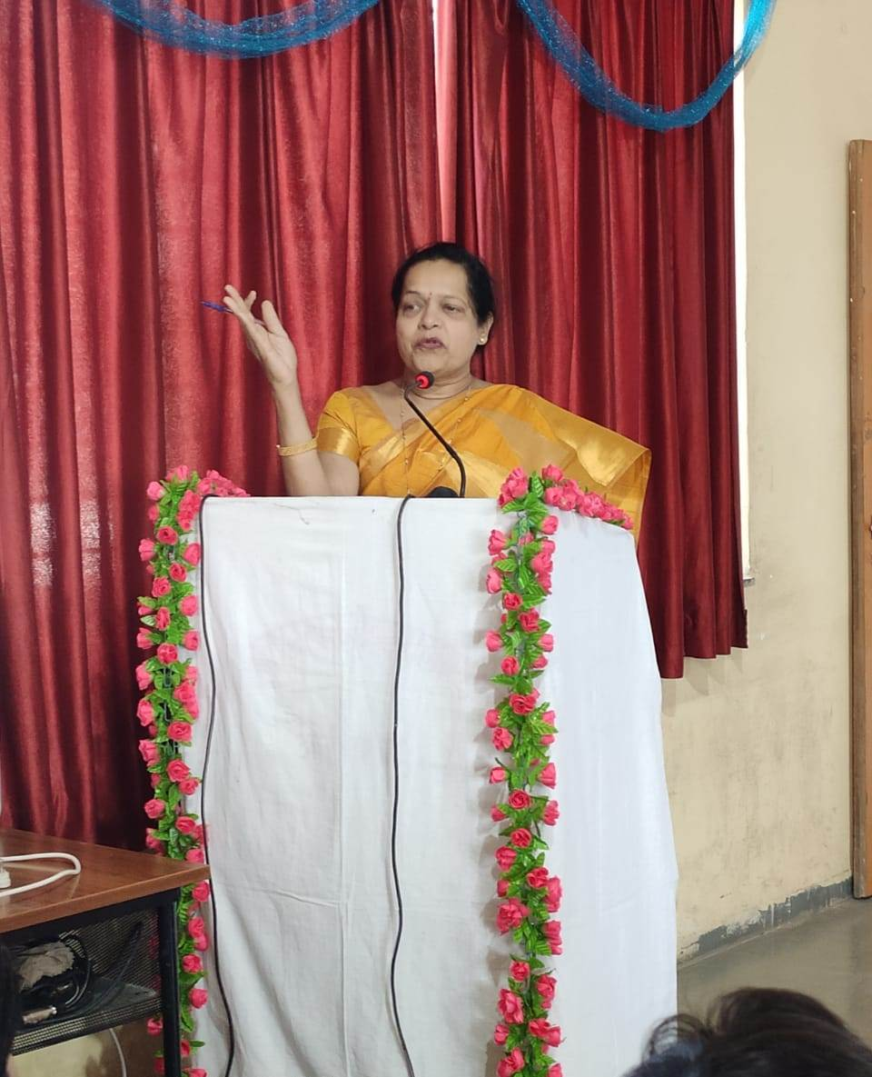

**Chief Guest Adv. Archana Gondhalikar addressing the gathering**

